**Learn and Improve your**

**Back Handspring**

**ELMWOOD GYMNASTICS ACADEMY**

**504-733-4496**

**700 Elmwood Park Blvd. Suite C**

**Harahan, LA 70123**

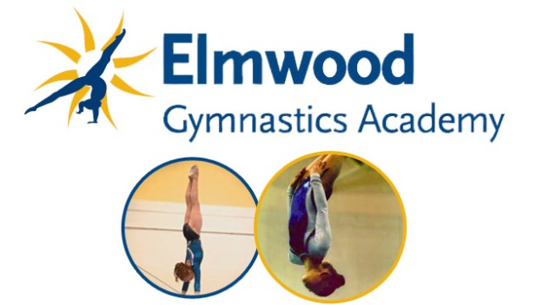

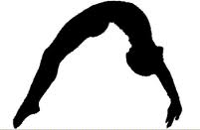

**Are you ready to take your skills to the next level?**

This is an EXCELLENT OPPORTUNITY to develop strength and technique to successfully complete a back handspring.

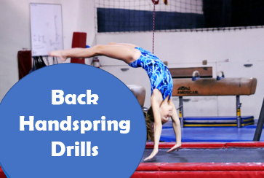

* Thursdays from 6:45-7:45pm
* All levels welcome (Ages 6+)
* $65/month
* Begins June 7th, 2018
* Walk-ins Welcome