HERITAGE PLAZA
CLASS DESCRIPTIONS

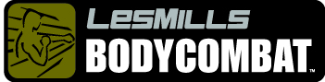 combines moves and stances developed from a range of self-defense disciplines such as karate, boxing, Tai Chi, and kickboxing. It is a fiercely energetic experience taught in a safe and simplistic manner. Designed to fight fat and kick calories, it is a great cardiovascular workout that's all out fun. (45 and 60 minute formats offered)
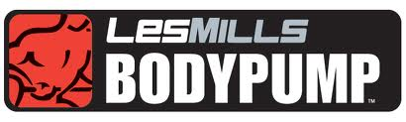 A rapid fat-burning class that uses barbells to give you the fastest way to tone and condition muscles! After an exhaustive study, BODYPUMP was verified by The University of Auckland as providing the fastest body fat loss of any fitness class. (45 and 60 minute formats offered. )

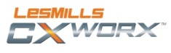 A 30-minute moderate to high intensity core program. Tightens and tones the core, improves functional strength for mobility and injury prevention.

Les Mills BODYATTACK® is a high-intensity cardio workout designed to build strength and stamina. This high-energy class combines sports-inspired athletic aerobic movements with strength and stabilization exercises

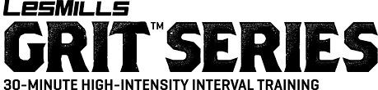
These HIIT workouts build cardiovascular fitness while improving strength, building lean muscle and maximizing calorie burn. The 30-minute cycle workout that uses high-intensity interval training to help you smash goals faster. Intermediate to advanced workouts.

BOOT CAMP – 45-60 minute athletic workout. Interval circuits that will consist of cardio, strength and core building exercises. Intermediate to advance exerciser

PILATES
Pilates - using lengthening, toning and strengthening exercises based on Pilate technique. Bring a mat and take your shoes off and get ready to stretch and tone yourself to a new level. Your back and abdominals will thank you. (All Levels)

SPINNING
40-60 minute ride taught within one of the Energy Zones (Endurance, Strength, Interval, Race Day and Recovery). Each class is taught within a certain Heart Rate parameter and cadence range. This class will fill the needs of the average cardio exerciser and the triathlete alike. Voucher ticket required for all classes. Tickets distributed at the front desk.

TRIYOGA ALL LEVELS
Yoga All Levels- This class is designed for the beginner students to the more advanced student. Students can work at their own level of practice as modifications will be given during class by the instructor. 60 minute class. Bring your yoga mat

ZUMBA®
ZUMBA® fusion of Latin & International music utilizing the principles of fitness interval training and resistance training to maximize caloric output, fat burning and total body toning. Mixes body sculpting with easy to follow dance steps.

